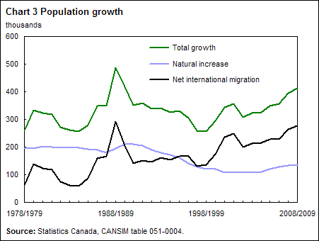

There are three graphs in the chart. The green graph shows the total growth of the population, the black one deals with the migrated people in Canada and the blue graph shows the natural increase of the population. In 1988/89 there was an enourmous growth. In the following years the total growth went down to about 250,000 in 1998/99. From that time on the Canadian population has been gradually growing again although the natural increase slows down. So we can say that the growth of the population in Canada is based on migration.
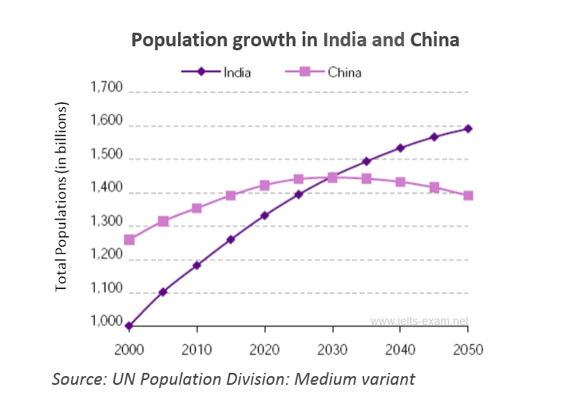

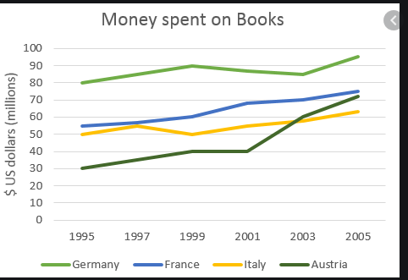Academic Writing Sample Task 1 #72
Complete the answer by filling the gaps with a word or phrase from the box below.
steadily | hovering | trend
meanwhile | rocketed | fluctuated
peak | plummeted | period
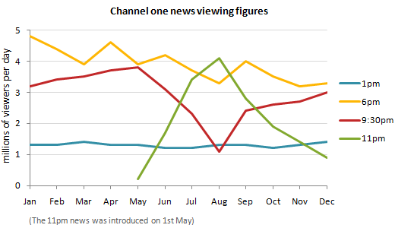

The chart shows the average daily viewing figures for Channel One News over a 12-month ..................... The figure for the 1pm News remained fairly stable, .................... at around 1.3 million throughout the year. The figure for the 6pm News began the year at 4.8 million. It ...................., but the general .................... was downwards, and it ended the year at 3.4 million.
The figure for the 9:30 News gradually increased from 3.2 million viewers per day in January to a .................... of 3.8 million in May. However, this month saw the introduction of the 11pm News, and the figure for the 9:30 News ...................., hitting a low-point of 1.1 million in August. In the same period, the figure for the 11pm news .................... from 0.2 million to 4.1 million. At this point, the trend reversed. From August onwards, the figure for the 9:30 news grew ...................., reaching 3 million by the end of the year. ...................., the figure for the 11pm News declined sharply, and in December fell below the 1 million mark.
Show Answers - Hide Answers

Vocabulary Tip
When talking about statistics we say that figures reach a peak of or peak at: The number of viewers reached a peak of 3.8 million / peaked at 3.8 million in May. The opposite of a peak is a low. The word trough also has this meaning, but is usually used together with the word peak: The number of viewers fell to a low of only 1.1 million in August. The figure has its peaks and troughs.

- « Previous
- Next »
Search ielts-exam.net:

SHARE THIS PAGE

CONTACT US | IELTS QUESTIONS | LIFE IN THE UK TEST
While using this site, you agree to have read and accepted our terms of use, cookie and privacy policy.
